**ASSEMBLY PROGRAMMING IN 8085**

**Basic Opcodes**

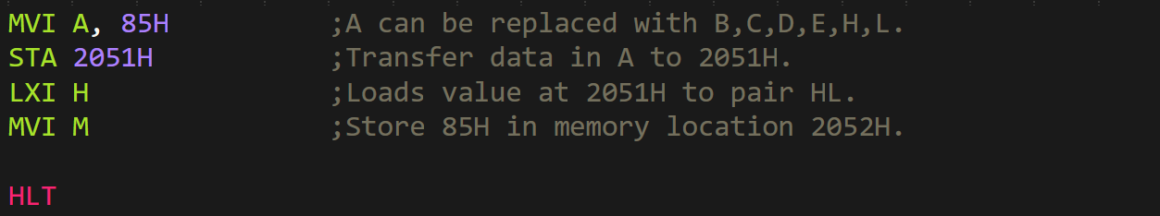

* In lines with **no** **address** mentioned, we can also **explicitly add** it if we want to.
* When **no** address is mentioned, then we are referring to **last mentioned value** or **address**.
* ***MVI*** means **Move Immediate**.
* ***STA*** means **Store Accumulator**.
* ***LXI*** means Load **Immediate Extended**.
* ***ADD*** adds **two** operands.
* ***MOV*** mean data transfer **one register to another**.
* ***MVI*** means directly move **integer value to a register**.